Jenkins with Locust

Check for the locust installation on (WSL) :
- sudo apt install python3-locust
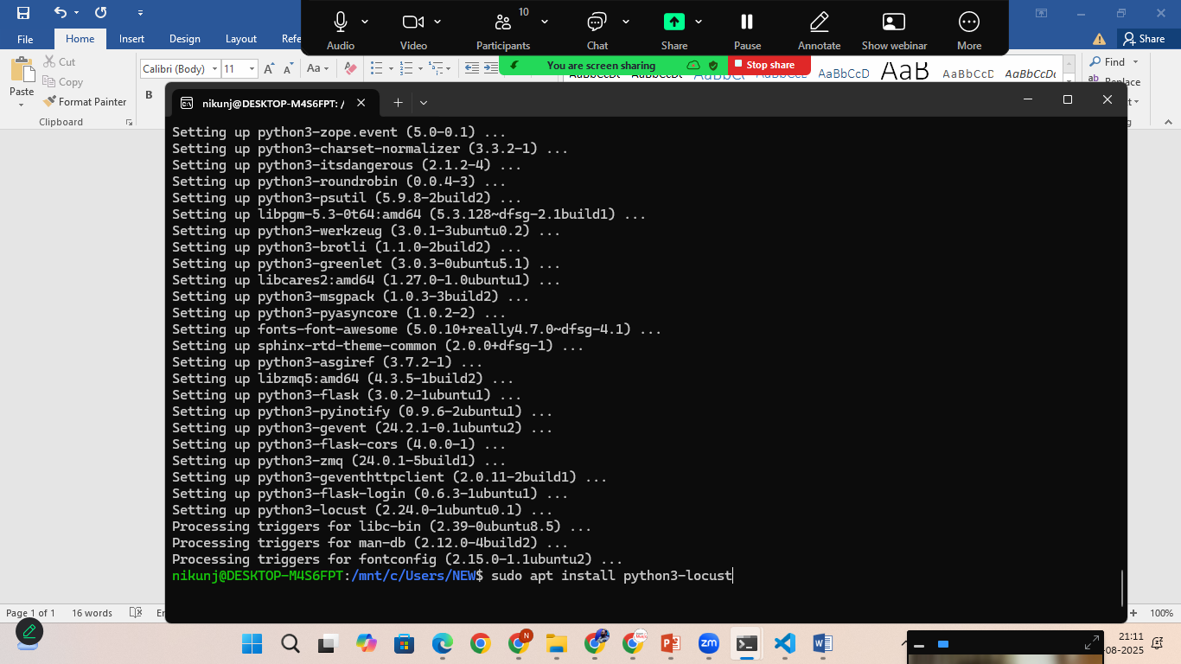
start the Jenkins
- sudo systemctl start Jenkins
create Jenkins pipline
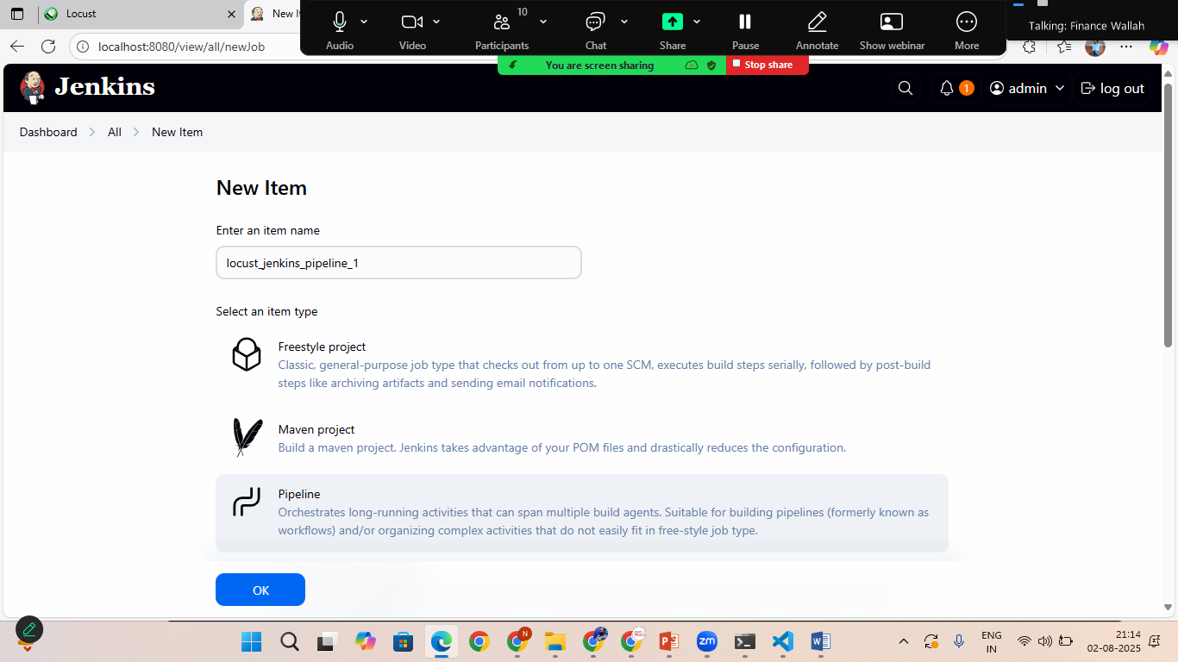

Create pipline:

Goto> wsl and create the locust file
- cd /var/lib/Jenkins/workspace/
- ls
- cd /<yourproject name>
- sudo touch locustfile.py
- sudo chmod –R u+W /var/lib/Jenkins/workspace/locust_jenkins_pipeline_1/locustfile.py
- sudo nano locustfile.py
copy the script:
from locust import HttpUser,task,between

class JsonPlaceholderUser(HttpUser):
wait_time=between(1,2)
host="https://jsonplaceholder.typicode.com"

@task
def getUsers(self):
self.client.get("/users")

- press ctr+s and ctr+x to save and exit
- goto> Jenkins and build the pipline

